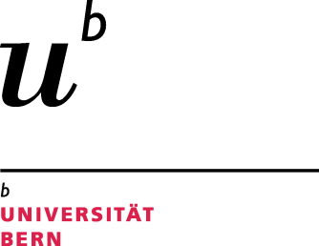

Science Faculty
Evaluation of Master thesis
MSc Program in Molecular
Life Sciences

1. Personal data of student
First names
(underline main)
Last name
Matriculation no. | xx-xxx-xxx | Birth date | dd-mm-yyyy

2. Personal data of supervisor
First names
(underline main)
Last name, Title
E-mail
Institution
Address
Telephone

3. Master thesis project
Starting date |  | dd-mm-yyyy
Extension granted  (otherwise termination date must be within one year after the start) |  | (select from pulldown menu) | dd-mm-yyyy
Termination date  (date when thesis was received by supervisor) |  | dd-mm-yyyy
Thesis title

4. Chosen specialisation (select one from pulldown menu)

Please return a copy of the signed evaluation form
and a pdf file of the thesis to: Prof. Norbert Polacek
Head of studies
Freiestrasse 3
(in addition both the evaluation form and the final master thesis
need to be sent electronically as pdf files to the Dean’s office)
Tel.: +41 (0)31 684 4320
norbert.polacek@unibe.ch
http://www.mls.unibe.ch

5. Evaluation:
(Please characterise each point with a few sentences. Your text should fully justify the grade and explain on which basis it was determined. This may be legally important in cases of dissent or later doubts about the student's performance.)
How do you evaluate the student's performance in studying the relevant scientific literature and in incorporating it in his/her thesis?
How would you qualify the scientific work of the student in terms of work organisation, personal effort, aptitude, creativity?
(taking into consideration the difficulty of the task)
Comment on the relevance of addressed questions and the quality of obtained results. Have the aims of the study been met?
How do you evaluate the student's analytical abilities and his/her interpretation of the results?
Comment on the writing and layout of the thesis including figures and tables:
How would you qualify the scientific maturity and independence of the student?
Further comments (optional):
Overall grade, if necessary with comments on how the different aspects were weighted
Grade (pulldown):
Comments (optional):

6. Participation in seminars:
With my signature, I declare that the student has attended 2 hrs of seminars, progress reports, journal clubs per week during the entire duration of the MSc thesis
(these form a required and integral part of the thesis to obtain the 60 ECTS points).

7. Signature:

Location: Signature supervisor
Date:

